Return to previous page | Return to show schedule

Seafood Entrees
Shrimp Marmara & Linguine 12.75
Shrimp Fra Diavalo & Linguine 12.75
Shrimp & Clams Fra Diavalo & Linguine... 14.75
Shrimp Parmigiana with Linguine 12.75
Shrimp Aglio Olio & Linguine 12.75
Shrimp Francese with Linguine 16.75
Steamed Clams & Linguine, Red Sauce 11.75
White Sauce... 11.75
Steamed Mussels & Linguine, Red Sauce 10.50
White Sauce.. 10.50
Calimari & Linguine, Red Sauce 10.50
Fried Calimari with Linguine 10.50
Combination Seafood & Linguine
(Shrimp, Gams, Mussels, Calimari) 13.50
Lobster Fra Diavalo & Linguine Priced Daily
Lobster, Shrimp, Clams & Linguine... Priced Daily
Fresh Fish of the Day & Linguine Priced Daily
Meat & Chicken Entrees
Veal Milanese 11.00
Veal Parmigiana 11.50
Veal Francese 11.50
Veal Marsala 11.75
Veal Pizzaiola 11.50
VealPiccatta 11.50
Roasted Veal Priced Daily
Ossobuco (Veal Shank) 12.50
Pork Chops 10.75
Sausage & Peppers 10.50
Sausage & Eggplant Parmigiana 13.50
Chicken Cacciatore 11.50
Chicken Parmigiana 10.50
Chicken Francese 11.50
Chicken Marsala 11.75
Chicken Zingara 11.50
Vegetable Entrees
Eggplant Parmigiana 10.50
Meat, Chicken, and Vegetable entrees served with a side order of Linguine with Marinara Sauce.

Deserts 
Cheesecake 3.50
Cannoli 3.50
Tiramisu 3.50
Tartufo Ice Cream 3.50
Spumoni Ice Cream 3.50
VICINO LUNCH MENU
Submarine Sandwiches
Steak & Cheese Sub 6.50
Thin sliced rib-eye steak and mozzarella cheese with lettuce, tomato, onion, and mayonaise.
Italian Sausage Sub 6.50
Mild Italian sausage with tomato sauce and melted mozzarella cheese.
Meat Ball Sub 6.50
Italian meat balls with tomato sauce and melted mozzarella cheese.
Chicken Parmigiana Sub 6.50
Breaded and sauteed chicken breast with tomato sauce and melted mozzarella cheese.
Chicken Cutlet Sub 6.50
Breaded and sauteed chicken breast with lettuce, tomato, and mayonaise.
Tuna Salad Sub 6.50
Tuna salad with lettuce, tomato, and mayonaise.
Italian Cold Cut Sub 6.50
Capocola Ham, Salami, Mortadela, Mozzarella Cheese with lettuce, tomato, and oil & vinegar.
Other Lunch Items
Pizza Calzone 6.50
Pizza dough, folded, filled with pepperoni, green pepper, onion, tomato sauce,mozzarella cheese, and baked.
Cheese Calzone 6.50
Pizza dough, folded, filled with tomato sauce, mozzarella cheese, and baked.
Chicken Caesar Salad 6.50
Chicken on a bed of fresh Romaine lettuce, with Caesar dressing.
Tuna Salad 6.50
Tuna salad on a bed of fresh garden greens.

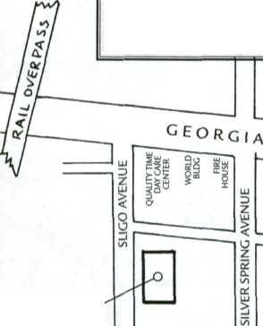
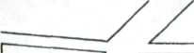
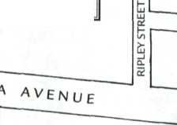
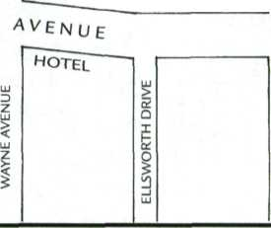
VICINO
RISTORANTE ITALIANO
Visit Vicino Today
OPEN EVERY DAY FOR LUNCH & DINNER OR CALL OR FAX YOUR CARRY-OUT ORDER 301/588-3372 301/585-8151 fax
CHEW CHASE BANK
DISCOVERY COMMUNICATIONS BUILDING

o u
llj <;
_i a.

